LAB TASK 1

1. Linear Search

Code:

#include<stdio.h>

int main(){

int n,key,found=0,i;

printf("Enter number of elements \n");

scanf("%d",&n);

int arr[n];

printf("Enter %d elements \n",n);

for(i=0;i<n;i++){

scanf("%d",&arr[i]);

}

printf("Enter element to be searched \n");

scanf("%d",&key);

for (i=0;i<n;i++){

if (arr[i]==key){

printf("The number is found at index %d",i);

found=1;

}

}

if(found==0)

printf("The number is not found");

return 0;

}

Output :

Case 1 : The number is found

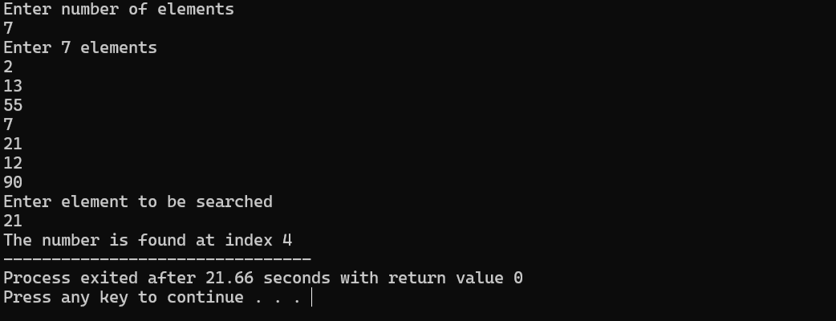

Case 2 : The number is not found

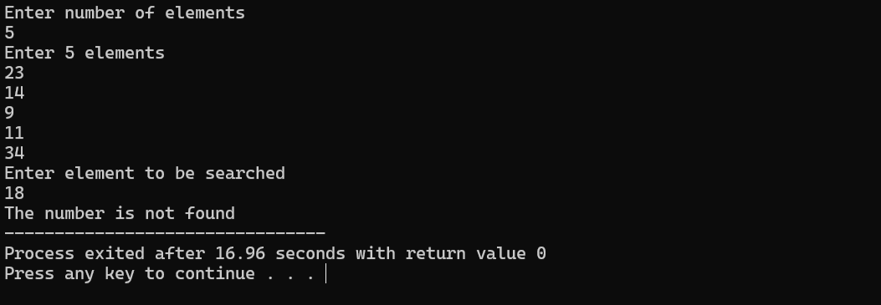

1. Binary Search

Code :

#include<stdio.h>

int main(){

int n,key,mid,found=0,i;

printf("Enter number of elements \n");

scanf("%d",&n);

int arr[n];

printf("Enter %d elements \n",n);

for(i=0;i<n;i++){

scanf("%d",&arr[i]);

}

printf("Enter element to be searched \n");

scanf("%d",&key);

int start=0;

int end=4;

while (start<=end){

mid=(start+end)/2;

if (arr[mid]==key){

found=1;

printf("The number is found at index %d",mid);

break;

}

else if (key>arr[mid])

start=mid+1;

else

end=mid-1;

}

if (found==0)

printf("The number is not found");

return 0;

}

Output :

Case 1 : The number is found

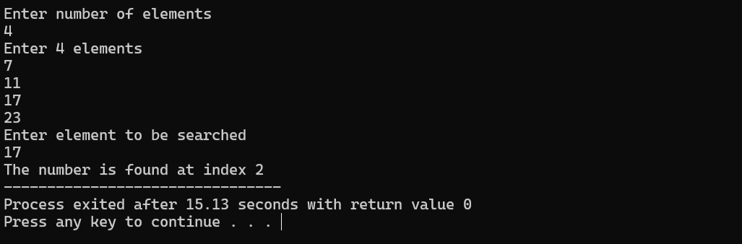

Case 2 : The number is not found

